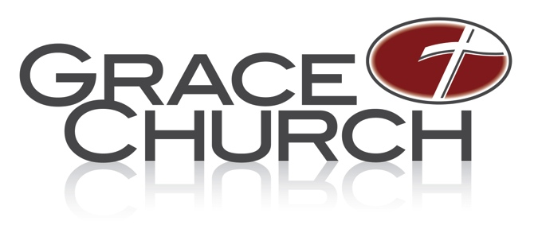
Job Description
Administrative Assistant
Campus: Bath

Ministry Area: Senior Pastor’s Office

Ministry Position: Administrative Assistant

Time commitment: 15 hours per week; part-time non-exempt hourly for Senior Pastor’s Office

Staff contact: Terri Baird, Assistant to the Senior Pastor

Position Overview:
As part of the office administrative team, this position provides administrative support for the office of the Senior Pastor. The purpose for this position is to provide exceptional administrative and organizational services with special attention given to supporting and solving the growing needs for the Senior Pastor’s Office.

Essential Job Functions
For the Executive Assistant to Senior Pastor
- Prepare Senior Pastor’s Expense Report
- Reconcile Senior Pastor’s church credit card statement
- Maintain Statistics: email ministry teams monthly to gather statistics; keep track and update reports and documents in Box and update GraceLink
- Assist with Senior Pastor’s Correspondence
- Manage the scheduling and communication of the monthly Bath Steering Team meeting
- Manage the scheduling and communication of the monthly Residents & Interns meeting
- Manage the Grace Church membership application process
- Track and keep current staff updates, update Senior Pastor’s contact list
- Plan travel for Senior Pastor: airline tickets, hotels, schedule, etc.
- Arrange events/plan meals/host - three-four times a year for Senior Pastor
- Keep Senior Pastor’s office stationary supplies stocked
- Cover Front desk - representing Sr. Pastor’s Office as needed.
- Make building reservations as needed
- All other tasks as requested.

Spiritual Life
- Growing in faith as a believer in Christ (2 Peter 1:5-11).
- Must have a teachable spirit and servant’s heart (Philippians 2:1-11).

General Requirements
- Must be a committed, regular attender of Grace Church Bath Campus.
- Must adhere to and support the vision and philosophy of Grace Church and its leadership, including the Statement of Faith.
- Must have attended or is in the process of attending Discovery.
- Must possess organizational and multi-tasking abilities and be able to handle stressful situations with self-control and teamwork.
- Confidentiality: Must be able to keep confidences and understand the sensitive nature of the Senior Pastor’s office.
- Must be able to work within a team environment.
- Must have the ability to maintain a high level of accuracy (exceptional attention to detail) in preparing and entering information and developing processes to efficiently get the work finished promptly.
- Must possess a strong work ethic (We are the recipients of the Lord’s money).
- Must have a heart focused on ministry, not just a job.
- Must be proficient and confident in your computer skills that include the programs of Microsoft Office; be willing to learn in-house management systems such as GraceLink.
- Must be willing to perform other duties as required in a spirit of servitude.

Measured by
- 30/60/90-day new hire review by the Executive Assistant to the Senior Pastor.
- Annual Review by the Executive Assistant to the Senior Pastor.

