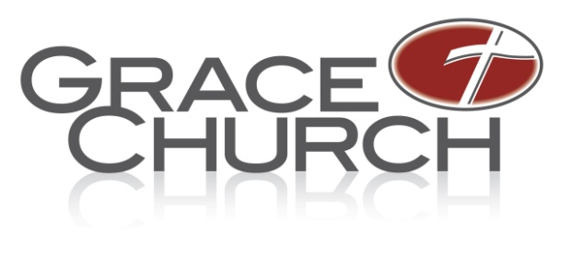
Job Description
Saturday night Custodian
Campus: Bath

Ministry Area: Administration

Ministry Position: Saturday Evening Custodian

Time commitment: 4 hours per Saturday, part-time non-exempt hourly

Staff contact: Cerina Sielski, Facilities Manager

Position Overview:
The purpose of this position is more than just cleaning. You are a vital part of Grace Church’s first impression to those who enter our buildings. Grace Church is passionate about making our guests and regular attendees feel comfortable and at home when they are in our buildings. Ultimately this allows them to relax and take in God’s word and truth that is being taught and shared. Being part of Grace Church’s team means you have a passion for the Lord and a passion to do all things with excellence and to live above reproach. Each person on the team views their role as a ministry more than a day-to-day job.
Essential Job Functions
- This includes tasks such as vacuuming, cleaning restrooms, restocking restrooms, wiping down all surfaces, washing windows, mopping floors, emptying trash, taking trash to the dumpster and other various “cleaning” tasks.

Job Requirements
- Strong attention to detail.
- Task oriented in being driven to accomplish all tasks required.
- This position is physically demanding and requires being able to lift a minimum of 30 lbs., with repetitive motions while standing all day.

Spiritual Life
- Growing in faith as a believer in Christ (2 Peter 1:5-11).
- Must have a teachable spirit and servant’s heart (Philippians 2:1-11).

General Requirements
- Must adhere to and support the vision and philosophy of Grace Church and its leadership and have attended or is in the process of attending Grace 101.
- A solid understanding of biblical community including participating in on-going biblical community at Grace Church.
- Must possess organizational and multi tasking abilities and able to handle stressful situations with self-control and teamwork.

- Must possess a strong work ethic (We are the recipients of the Lord’s money).
- Self-directed and a self-starter. Able to work independently with minimal supervision. Pro-active and dependable.
- Must have a heart that is focused on ministry, not just a job.
- Handles confidential matters and material with integrity and humbleness within a team environment. Requires an intuitive understanding of sensitive ministry information. Communicates information to pastoral staff as appropriate.
- Must have the ability to maintain a high level of accuracy in preparing and entering information developing processes to efficiently get the work finished promptly.
- Must be willing to perform other duties as required in a spirit of servitude.

Measured By
- 30-60-90 Review given by the Facilities Manager.
- Annual Review by the Facilities Manager.
- Input from staff and volunteers.

