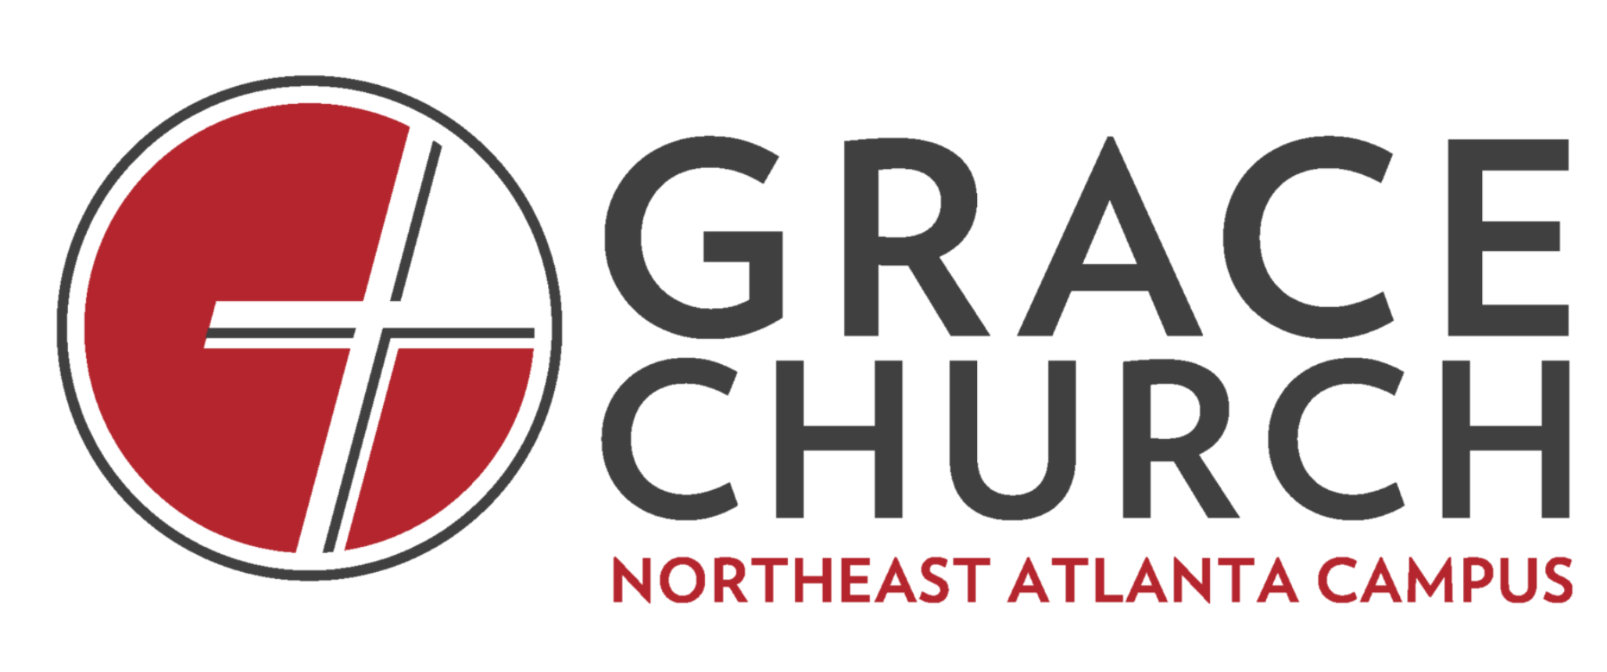

January 24, 2021
The Deeply Formed Life: Missional Presence
Luke 4:16-21
Virtual Life Group Discussion Questions

Announcements:
  - Prayer on Wednesdays at 8:00PM
  - Giving – If you want to give online, you can do so at neatlanta.gracechurches.org (there is a ‘GIVE’ tab on the top right of the homepage). We appreciate your sacrificial generosity!
  - January Series: The Deeply Formed Life Please read chapters 9 & 10 for further understanding of the habit of missional practice.

Icebreaker:
Let’s briefly introduce ourselves and share a high and low from the week.

Discussion Questions:
- What stuck out to you from the message?
- A missional community starts with a missional God, is empowered by God, is called to justice and is infused with hope. Which of these points resonates with you?
- Why is it important that God reached out to us when reaching out to others?
- When was a memorable time you were drawn to a spiritual community? What drew you there?
- There is a dichotomy in Christianity between truth and justice. Why is this so?
- How has Jesus given you hope in this season?
- Why is hospitality such a powerful expression of God’s love?
- How has someone’s hospitality significantly impacted you?
- How is working for justice an act of following Christ?
- Why is it important to work for God in whatever you do?
- Why is it crucial to share the message of Jesus? Why is it so hard to?
- What are ways we can pray for each other this week?

Growth Group Questions:
- How can we start living a missional lifestyle this week?
- Who are the people we could show hospitality to in the coming months?

Pray together

