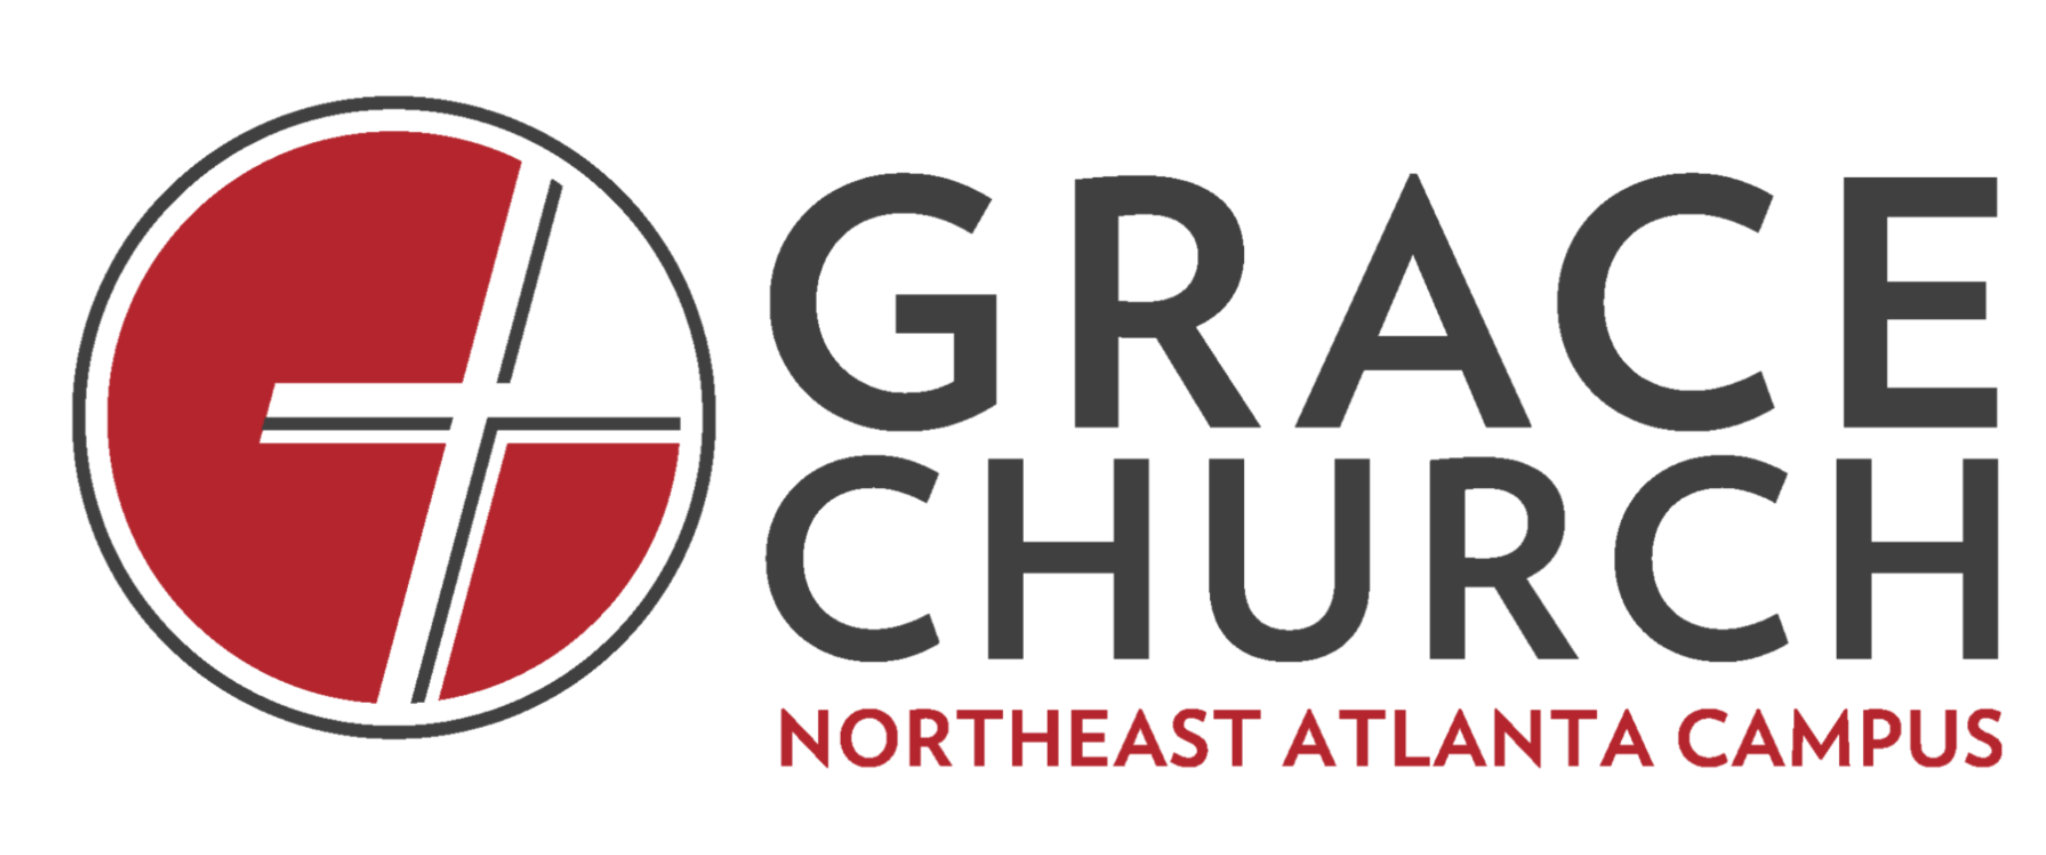

November 22, 2020
Imagine being a church on mission
Psalm 67
Virtual Life Group Discussion Questions

Announcements:
  - Prayer on Wednesdays at 8:00PM
  - Hybrid Gatherings – We encourage everyone to observe safety protocols and social distancing guidelines.
  - Giving – If you want to give online, you can do so at neatlanta.gracechurches.org (there is a ‘GIVE’ tab on the top right of the homepage). We appreciate your sacrificial generosity!

Read Psalm 67

Discussion Questions:

Icebreaker:
Describe a memorable holiday celebration you have enjoyed whether it was growing up or recently.

- What stuck out to you from the message?
- God’s mission is to save us, to extend His kingdom, and will be accomplished through us. Which of these points relate to your life in this season?
- Why is it important to know God’s ways when it comes to life?
- If you follow Jesus, when has God delivered you, or saved you? It could be when you decided to follow Jesus or another more recent situation that you have faced.
- If you follow Jesus, when it a memorable time when you enjoyed God personally or with church, family, or friends?
- How has God’s rule/sovereignty, or guidance helped you through 2020?
- God’s mission to extend His kingdom to “all people”. How is a multi-ethnic church uniquely positioned to express this reality?
- Why is God’s physical care an important aspect in the Psalms?
- God’s mission is to bless us. How does that truth impact you?
- The Psalmist hopes that “the ends of the earth will fear him [God]”. What are your thoughts about this statement?
- How can we join God in His mission this week?

Pray together

